**17th CENTURY**

**Technology:**

As the silk was picked, unravelled and reeled by hand and woven into fabric by a manually operated loom (invented in the 1400s), the process of producing silk fabrics was costly and time consuming and required extensive labouring. Therefore it was only used on the garments and corsets of noblewomen.

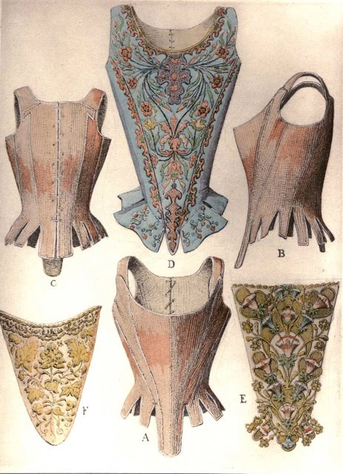

**Material Available:** The higher class women and noblewomen wore woven silk fabrics and used whale bone or “busk” boning to provide the constricting tightness of a corset.

**Fashion Trends:** The wearing of corsets became widespread in the 1500s and 1600s, as seen in many Renaissance portraits. The desired silhouette was not the hourglass but a dropped and extended waist, made so that the torso appears to be in a conical form. Lace and draping were the most common ways a corset was embellished, sometimes with jewelled ornaments.

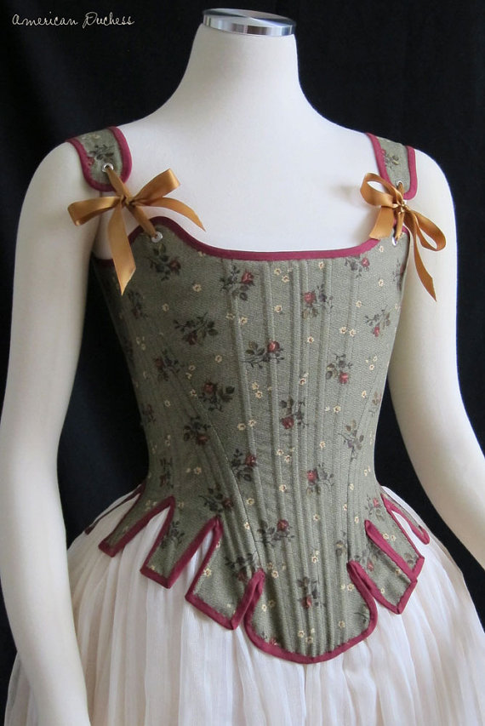

**Materials Available:**

The main fibres available at the time were natural fibres like cotton, wool and silk. Indian cottons were imported in large amounts to Europe. Silk threads were used for embroidery of patterns. Whale bone along with some steel caging were used to make corsets strong and structured.

**Fashion Trends:**

Women's silhouettes featured small, domed hoops in the 1730s and early 1740s which were inspired by Marie Antoinette and her court. Bodices stiffened with whalebone were used to create cone-shaped torsos with dropped waists.

**Technology:** Sewing machines were not invented until the 1800s so all corsets were hand sewn and all materials were natural. Materials were woven together with a loom

**18th CENTURY**

**Technology:** There was limited technology and machinery at the time to produce corsets, therefore many were sewn by hand to the wearer's measurements. Sewing machines were just being introduced to support the booming market in cheaper mass-produced corsets.

**19th CENTURY**

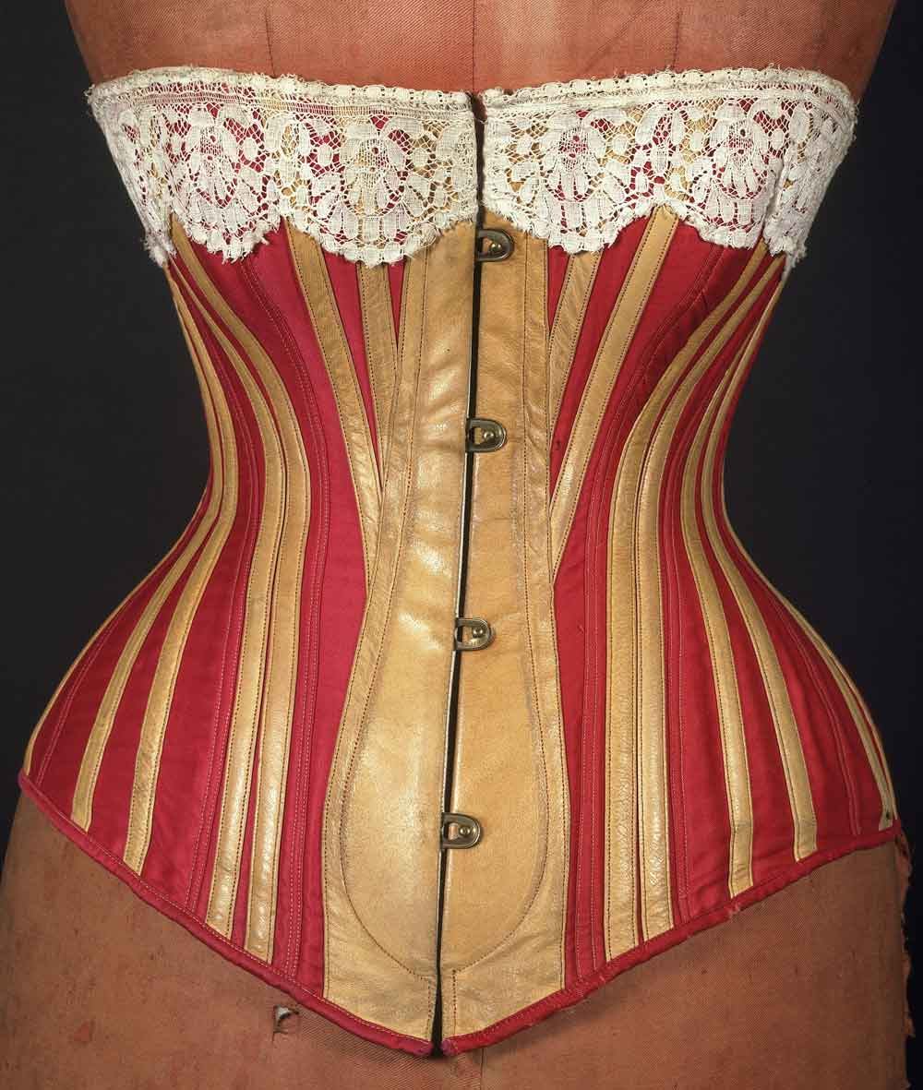

**Materials Available:** There were only natural fibres available which had to be made into fabric using a weaving loom. Corsets were typically constructed of a flexible material such as cloth, particularly coutil, or leather, which was stiffened with boning made from bones of elephant, moose, and whale.

**Fashion Trends:** Due to skirts being wider at the beginning of the century and the increasing size of the sleeves, the waist of the corset dropped back to its normal position. In the 1840s the corset lost its shoulder straps after the décolletage on evening dresses had become lower showing exposed shoulders.

**20th CENTURY**

**Technology:** Improvements in technology leading to the production of better and strong materials and elastics. Increase use of the new electric sewing machines allowing for higher speed, accuracy and safety.

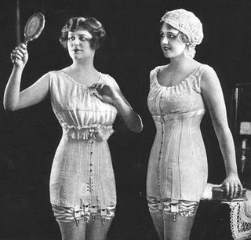

**Materials Available:** Man-made fibres were being introduced allowing for experimentation with a variety of fibres, natural and man-made, in creating new materials to better support the structure of the corset. However, as corsets became less popular and were being altered and made longer, elastic was being introduced into these longer corsets. Eventually, elasticised material was being introduced as girdles became more popular.

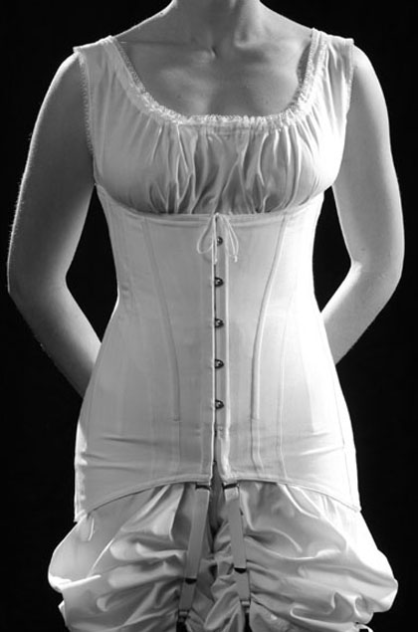

**Fashion Trends:** In the 1920s corsets turned into lightly stiffened hip girdles partly made of elastic to control the belly and hips due to the new fashion of a straight and waistless silhouette. In the middle of the century corsets were no longer necessary to be worn as under garments due to the flared skirts which were popular at the time. Then in the 1980s, Madonna wore her own version of the corset worn as an outer garment.

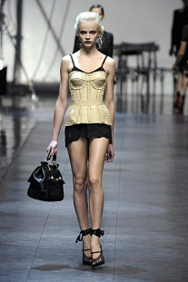

**Fashion Trends:** Corsets are not necessary as undergarments with the current fashion trends. However ‘shapewear’ is very commonly used and is from elasticised fabric. Corsets are still worn today, however they serve a different purpose to what they previously did. Singers such as Lady Gaga, Katy Perry and Rhianna have had an influence on the use of corsets worn as outer garments as they have been pictured wearing them on stage as well as red carpet events. Fashion designers have also incorporated the corset into the design of everyday clothing.

**Materials Available:** Today there are a wide variety of natural and man-made fibres to create all sorts of materials.

**21th CENTURY**

**Technology:** There are many new forms of technology to construct the pattern for the corset, material and embellishments for the corset and the corset itself. Sewing machines now have the ability to perform many tasks which previously would have to be done by hand or very meticulously with a sewing machine with limited features. There is also new technology for different pattern designs on material and decoration on corsets as well as newer and faster methods of making the fabric.