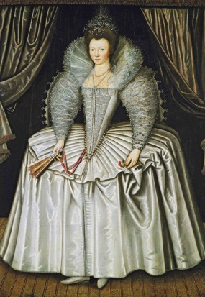

The ideal female figure is a conical form with a low waist and broad shoulders. The corsets are long in the front and short at the sides, exposing the hips. The necklines are low, revealing the tops of the breasts.

**17th CENTURY**

1595 - 1620

Short corsets are worn under short waisted bodices. The waist remains ideally small.

1620 - 1640

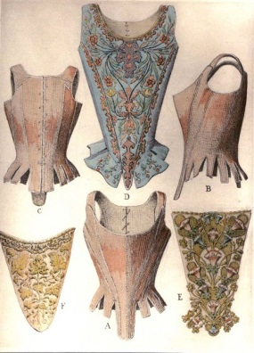

1660s

The round shape of women’s corsets was achieved by a tightly boned bodice with strips of whale bone inserted into finely stitched channels. These corsets had dropped waists and separate sleeves that were tied to the sleeves at the shoulder.

The bodice with off-the-shoulder separate sleeves returns to an elongated form, and the corset reflects this neckline and silhouette. Highly boned bodices are sometimes worn in lieu of a corset.

1670 - 1680

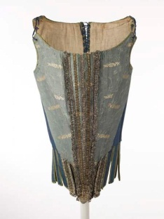

1670 - 1680

The new, angular silhouette continues to lengthen, emphasizing a straight, vertical line. Corset straps return to the shoulders.

**18th CENTURY**

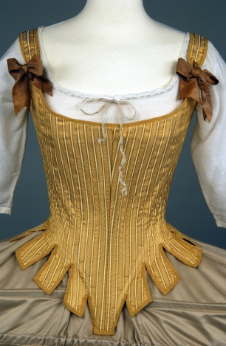

Corsets continue to be conical in shape and generally lace up the back. Decorative stomachers are worn on the outside of the stays as part of the gown ensemble. The stays separate at the base into tabs that splay over the hips and accentuate a tiny waist.

1700 - 1770

1770 - 1780

A tight-laced waist is the current trend especially in England and France; tight lacing is seen as a sign of morality. In France, the wearing of stays begins to fall out of fashion.

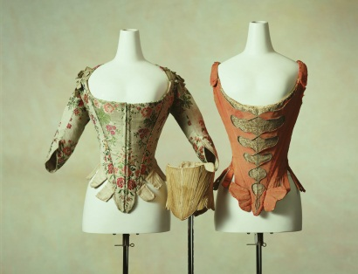

The corset adopts a rounded form that accommodates the natural contours of the breasts. Over the remaining years of the century, the waist gradually shortens.

1780 - 1789

1789 - 1810

During the French Revolution aristocratic styles are frowned upon, including the wearing of stays. High-waisted, neoclassical gowns bring the focus from the waist to the bosom.

1800s

Dresses of this time were made from soft muslin which clung to the body highlighting the figure of the woman.

**19th CENTURY**

**Industrial Revolution**

1820-1840

After 1820s

Corsets were worn again by all women

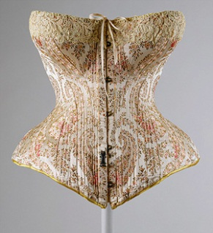

High waist dropped to its normal position on the waist and corsets were used to show off the narrow waist

1825

Lacing eyelets with hammered-in metal grommets are invented

1829

1828

A new form of fastening the corset was introduced. Two metal strips, with little mushroom-shaped heads on one side and eyelets on the other, known as the planchet.

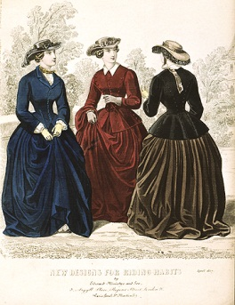

Basque shaped pieces were added to the hips

Mid 1830s

A new style of corset was introduced which was made from seven to thirteen individual pieces. They were made from strong white twill cotton with whale bone shaped to the natural body shape to further extenuate the waist and laced at the back.

1840

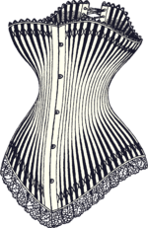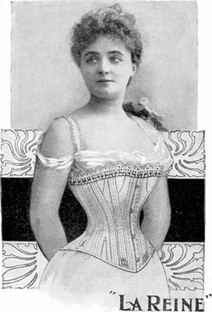

1880s

1890s

Tight lacing became popular to achieve the desired small waist

Corsets became longer as silhouettes hugged the hips on all sides

Corsets were fastidiously made, some with embroidery and satin fabrics in a variety of colours, moving away from the plainly made corsets.

1860s

Emphasise is placed on beautiful fabrics and elegant lines for corsets

As corsets became an obligatory part of fashion, tailors began to experiment with the traditional hourglass shaped corset.

1850s

A less restricting design known as ‘Health Corsets’ were designed to aid women to breathe. Mme. Gaches-Sarraute of Paris introduced the straight fronted busk for women so their abdomen was supported and raised instead of it traditionally being compressed and forced down. This design removed pressure from the vital female organs which was a concerning issue with the previous style of corsets.

1890s – 1900s

1870s – 1890s

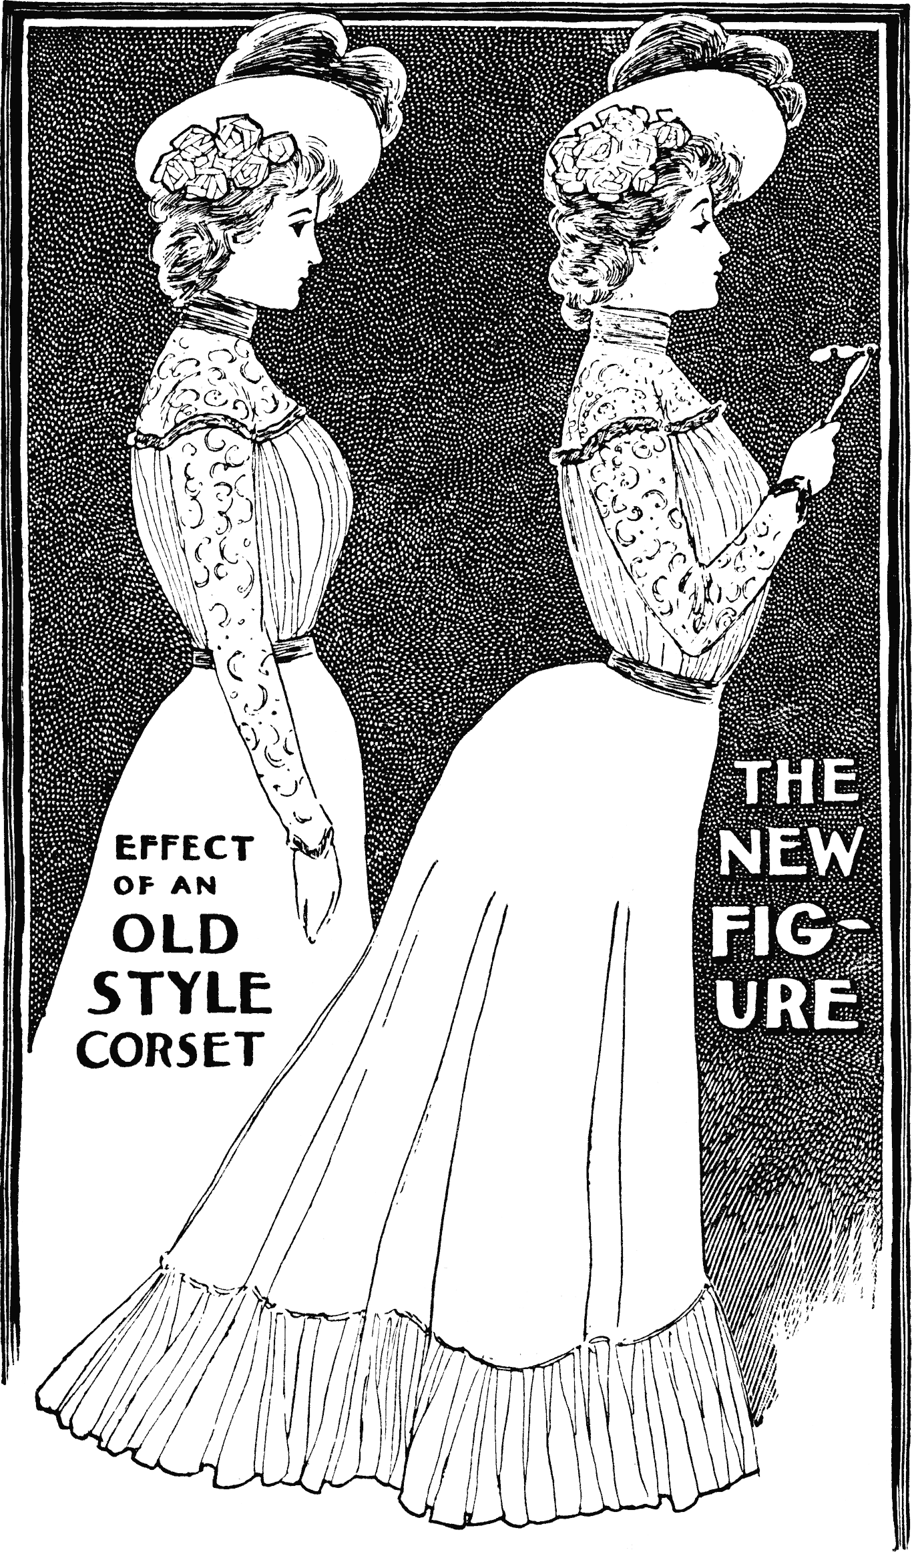

**20th CENTURY**

Fashion exploited the curves of an elaborately corseted figure. The corsets would distort women’s figures into an ‘S’ shape bend.

Edwardian Era

Starts 1901

1900s

1907

1910s

The health corset created a tiny waist and the straight fronted busk forced the bust forward and the hips back creating the ‘S’ shape. This shape became very popular but was more uncomfortable and harmful than any other designed corset before. Women’s figures into an ‘S’ shape bend.

The wasp waist decreased in popularity as corsets became straighter to achieve a long slim silhouette. The corset was fitted well to the thighs and began just above the waist. Elastic gusset inserts were introduced into the design of the corset as a feature to increase comfort.

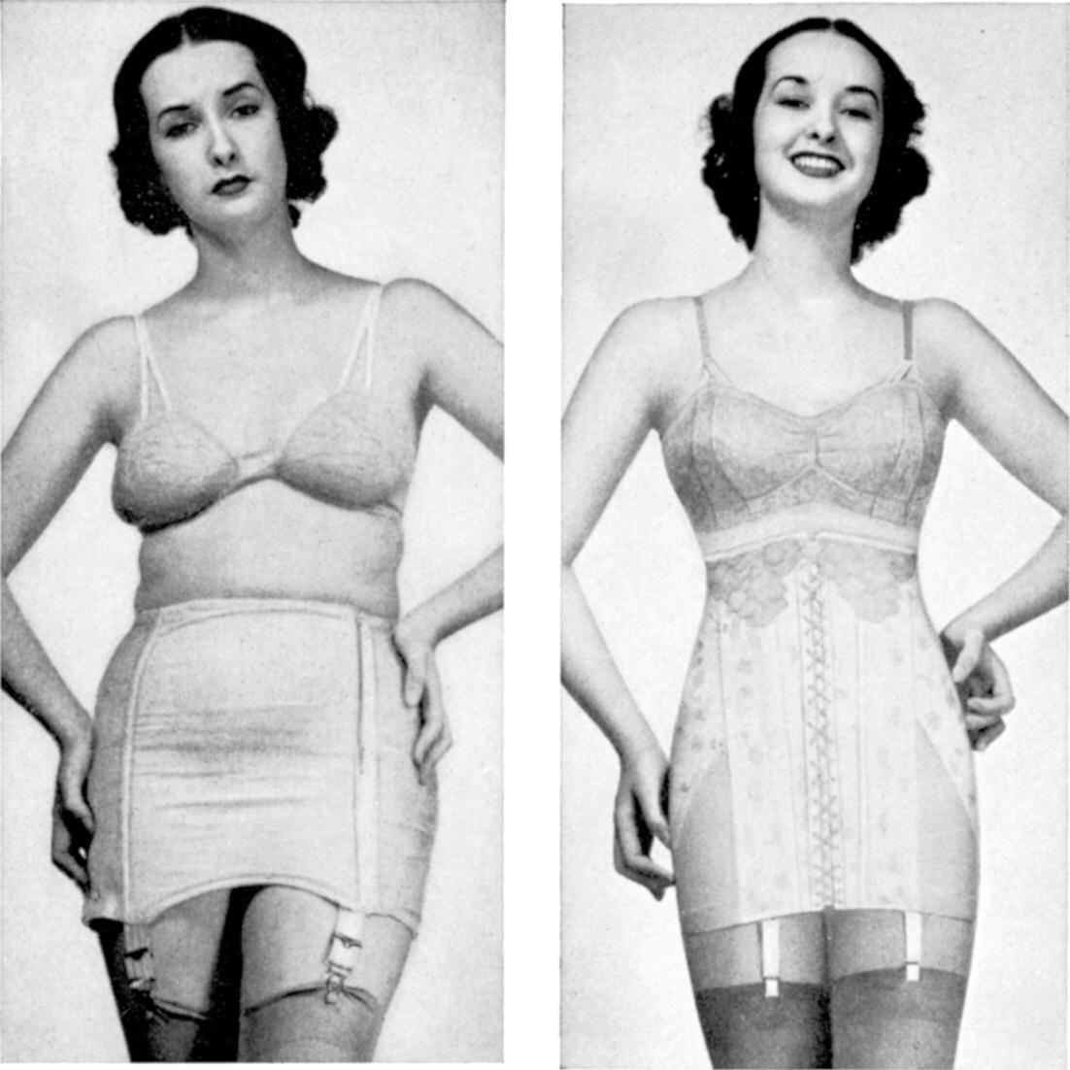

Corsets reached further down the thigh therefore elastic inserts were introduced to allow more room for movement

1912

1914

1915

Corsets became longer, almost reaching the knees, to go with the new longer, slimmer dress styles of the time.

Corsets became less popular as they become unnecessary with the current fashion trend

WWI begins

1920s

Corsets turned into lightly stiffened hip girdles partly made of elastic to control the belly and hips due to the new fashion of a straight and waistless silhouette.

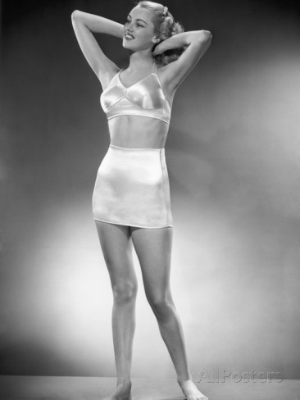

Girdle and bra still used.

1930s – 1940s

Elastic girdles without boning came back.

1950s

1960s – 1970s

Fashion trends and influences of the time got rid of the idea of corsets and girdles altogether.

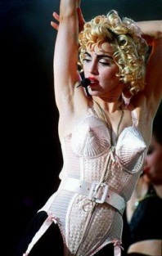

Music icon, Madonna along with designer, Gaultier brought back the idea or corsets as an outer garment bodice

1980s

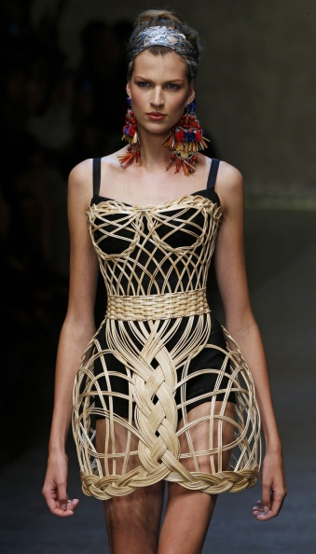

Corsets are rarely worn as undergarments, but sometimes as lingerie or as part of costumes. Celebrities, however, wear them as costumes of fashion statement and now have begun to slowly see corsets or elements of corsets subtly make their way into everyday clothing. Some elements of corsets such as structured torso panels are incorporated into modern trends.

Today

**21st CENTURY**